**Stereo calibration procedure**

Print template of chess board.

5x7 inner squares.

Each 30mm sized (real).

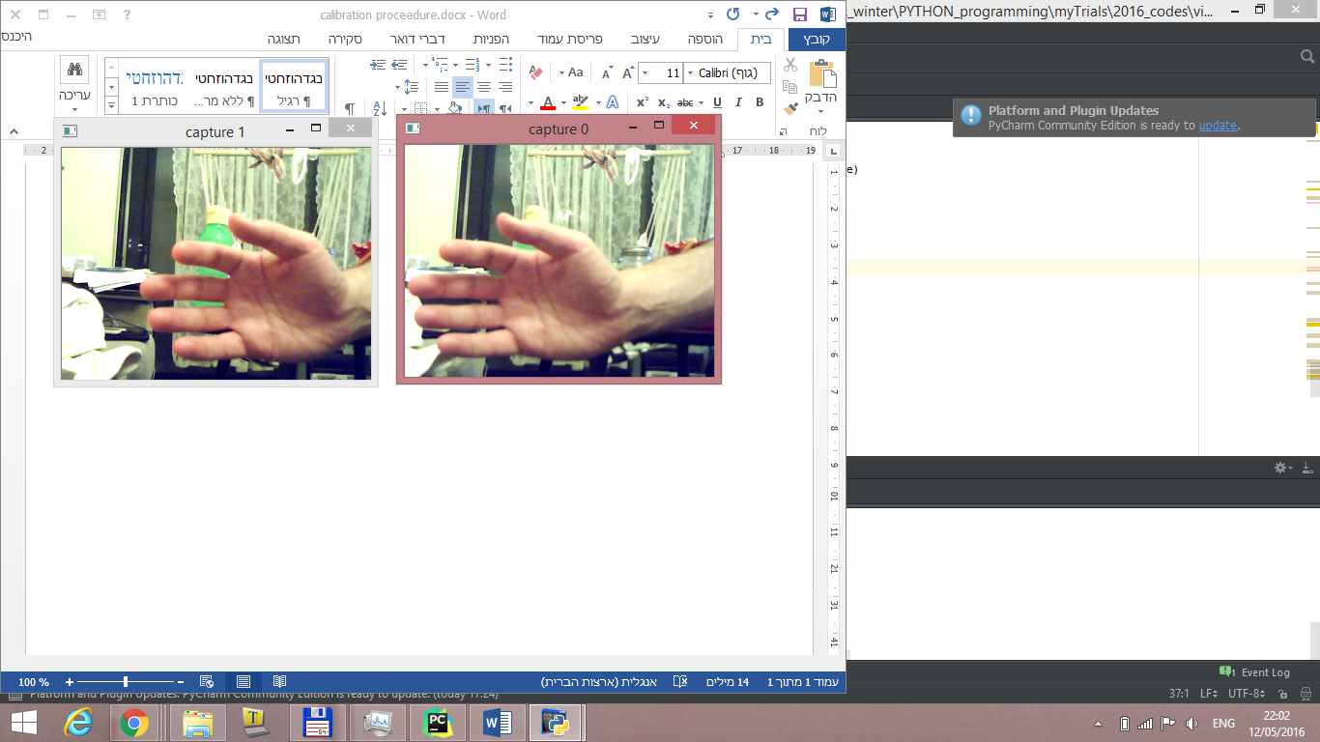

0 index camera is the robots right camera.

(from the viewer perspective – it’s the left camera side of the robot’s front).

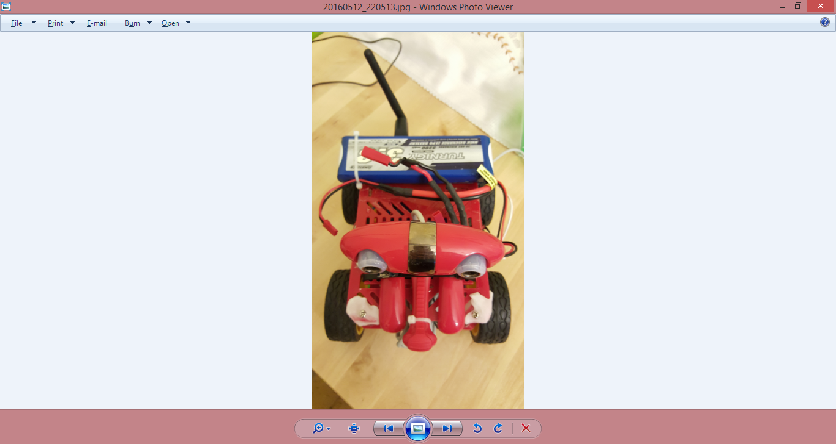

#0